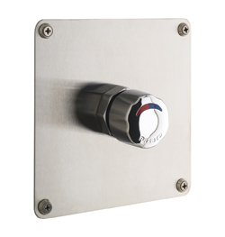
SELF CLOSING MIXER TAP FOR SHOWER
single control mixer tap with automatic time delayed shut-off
Inlet 1/2 ''
Flow rate 8L/mn at 417 kPa
Flow duration from 20 to 35 sec
self cleaning mechanism with ruby,
anti-corrosion and anti-liming materials,
flow regulator and temperature limit.
Chrome plated brass knob
For concealed installation.

